SELECT AVG(`RETAIL SALES`) AS avg_beer_sales
FROM warehouse_and_retail_sales
WHERE `ITEM TYPE` = 'Beer';
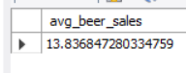
SELECT SUM(`RETAIL SALES`) AS total_beer_sales
FROM warehouse_and_retail_sales
WHERE `ITEM TYPE` = 'Beer';
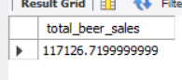
SELECT SUM(`RETAIL SALES`) AS total_wine_sales
FROM warehouse_and_retail_sales
WHERE `ITEM TYPE` = 'Wine';
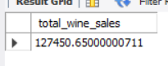
SELECT SUM(`RETAIL SALES`) AS total_liquor_sales
FROM warehouse_and_retail_sales
WHERE `ITEM TYPE` = 'Liquor';
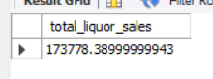
SELECT SUM(`RETAIL SALES`) AS total_keg_sales
FROM warehouse_and_retail_sales
WHERE `ITEM TYPE` = 'Kegs';
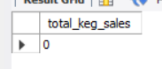
SELECT SUM(`RETAIL TRANSFERS`) AS total_keg_transfers
FROM warehouse_and_retail_sales
WHERE `ITEM TYPE` = 'Kegs';
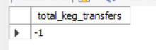
SELECT SUM(`WAREHOUSE SALES`) as keg_warehouse_sales
FROM warehouse_and_retail_sales
WHERE `ITEM TYPE` = 'Kegs';
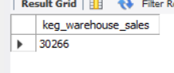
SELECT SUM(`RETAIL SALES`) as total_2017_sales
FROM warehouse_and_retail_sales
WHERE `YEAR` = '2017';
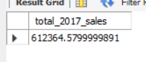
SELECT SUM(`RETAIL SALES`) as total_2017_beer_sales
FROM warehouse_and_retail_sales
WHERE `YEAR` = '2017'
And `ITEM TYPE` = 'Beer';
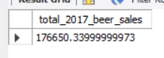
SELECT SUM(`RETAIL SALES`) as total_2017_liquor_sales
FROM warehouse_and_retail_sales
WHERE `YEAR` = '2017'
And `ITEM TYPE` = 'Liquor';
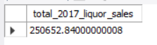
SELECT `ITEM TYPE`,
SUM(`RETAIL SALES`) AS total_sales_2017
FROM warehouse_and_retail_sales
WHERE `YEAR` = '2017'
GROUP BY `ITEM TYPE`
ORDER BY total_sales_2017 DESC;
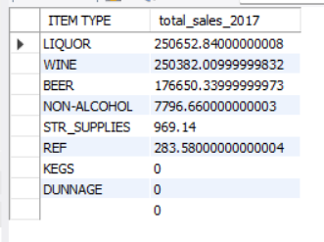
SELECT `ITEM TYPE`,
SUM(`RETAIL SALES`) AS total_sales_2017
FROM warehouse_and_retail_sales
WHERE `YEAR` = '2018'
GROUP BY `ITEM TYPE`
ORDER BY total_sales_2018 DESC;
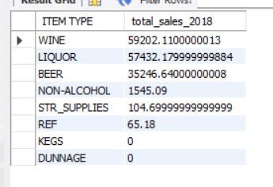
SELECT `ITEM TYPE`,
SUM(`RETAIL SALES`) AS total_sales_2019
FROM warehouse_and_retail_sales
WHERE `YEAR` = '2019'
GROUP BY `ITEM TYPE`
ORDER BY total_sales_2019 DESC;
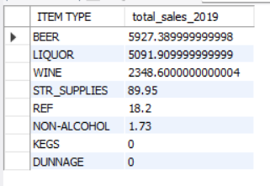
SELECT `ITEM TYPE`,
SUM(`RETAIL SALES`) AS total_sales_2020
FROM warehouse_and_retail_sales
WHERE `YEAR` = '2020'
GROUP BY `ITEM TYPE`
ORDER BY total_sales_2020 DESC;
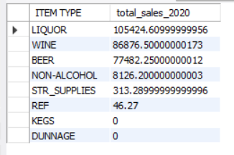
SELECT
`ITEM TYPE`,
SUM(`RETAIL SALES`) AS total_sales_2017,
(SUM(`RETAIL SALES`) * 100.0 /
(SELECT SUM(`RETAIL SALES`)
FROM warehouse_and_retail_sales
WHERE `YEAR` = '2017')
) AS percentage_of_2017_sales
FROM warehouse_and_retail_sales
WHERE `YEAR` = '2017'
GROUP BY `ITEM TYPE`
ORDER BY percentage_of_2017_sales DESC;
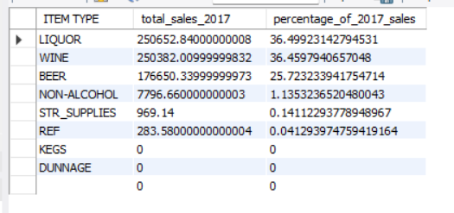
SELECT
`ITEM TYPE`,
SUM(`RETAIL SALES`) AS total_sales_2018,
(SUM(`RETAIL SALES`) * 100.0 /
(SELECT SUM(`RETAIL SALES`)
FROM warehouse_and_retail_sales
WHERE `YEAR` = '2018')
) AS percentage_of_2018_sales
FROM warehouse_and_retail_sales
WHERE `YEAR` = '2018'
GROUP BY `ITEM TYPE`
ORDER BY percentage_of_2018_sales DESC;
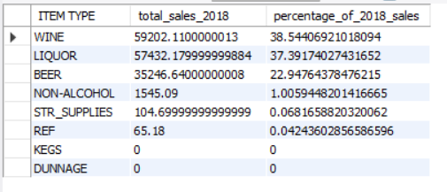
SELECT
`ITEM TYPE`,
SUM(`RETAIL SALES`) AS total_sales_2019,
(SUM(`RETAIL SALES`) * 100.0 /
(SELECT SUM(`RETAIL SALES`)
FROM warehouse_and_retail_sales
WHERE `YEAR` = '2019')
) AS percentage_of_2019_sales
FROM warehouse_and_retail_sales
WHERE `YEAR` = '2019'
GROUP BY `ITEM TYPE`
ORDER BY percentage_of_2019_sales DESC;
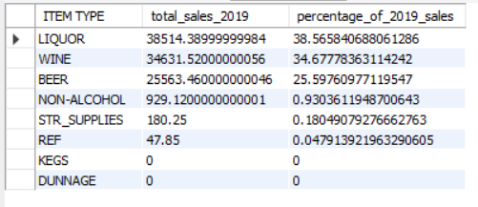
SELECT `ITEM TYPE`,
SUM(`RETAIL SALES`) AS total_sales_2020,
(SUM(`RETAIL SALES`) * 100.0 /
(SELECT SUM(`RETAIL SALES`)
FROM warehouse_and_retail_sales
WHERE `YEAR` = '2020')
) AS percentage_of_2020_sales
FROM warehouse_and_retail_sales
WHERE `YEAR` = '2020'
GROUP BY `ITEM TYPE`
ORDER BY percentage_of_2020_sales DESC;
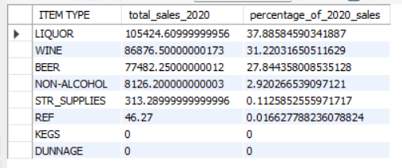
SELECT
`ITEM DESCRIPTION`,
`ITEM TYPE`,
SUM(`RETAIL SALES`) AS total_sales_2017
FROM warehouse_and_retail_sales
WHERE `YEAR` = '2017'
GROUP BY `ITEM DESCRIPTION`, `ITEM TYPE`
ORDER BY total_sales_2017 DESC
LIMIT 10;
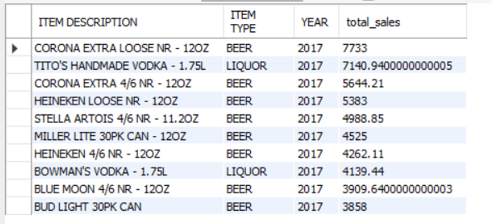
SELECT
`ITEM DESCRIPTION`,
`ITEM TYPE`,
SUM(`RETAIL SALES`) AS total_sales_2017
FROM warehouse_and_retail_sales
WHERE `YEAR` = '2017'
AND `ITEM TYPE` = 'Beer'
GROUP BY `ITEM DESCRIPTION`, `ITEM TYPE`
ORDER BY total_sales_2017 DESC
LIMIT 15;
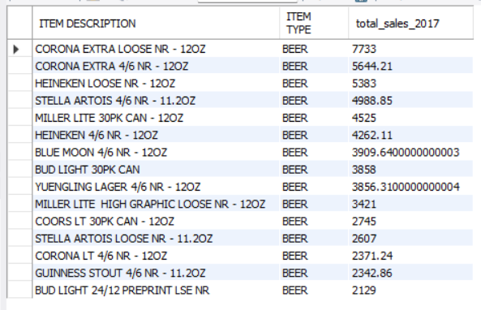
SELECT
`ITEM DESCRIPTION`,
`ITEM TYPE`,
SUM(`RETAIL SALES`) AS total_sales_2017
FROM warehouse_and_retail_sales
WHERE `YEAR` = '2017'
AND `ITEM TYPE` = 'Liquor'
GROUP BY `ITEM DESCRIPTION`, `ITEM TYPE`
ORDER BY total_sales_2017 DESC
LIMIT 15;
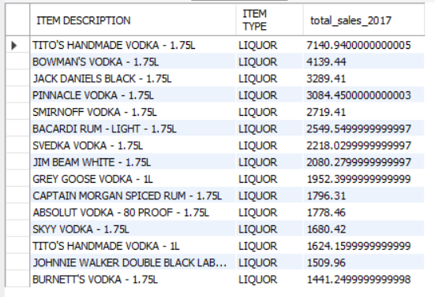
SELECT
`ITEM DESCRIPTION`,
`ITEM TYPE`,
SUM(`RETAIL SALES`) AS total_sales_2017
FROM warehouse_and_retail_sales
WHERE `YEAR` = '2017'
AND `ITEM TYPE` = 'Wine'
GROUP BY `ITEM DESCRIPTION`, `ITEM TYPE`
ORDER BY total_sales_2017 DESC
LIMIT 15;
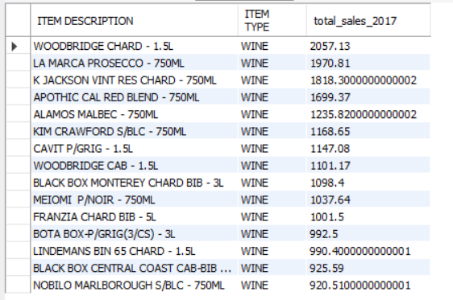
SELECT
`ITEM DESCRIPTION`,
`ITEM TYPE`,
SUM(`RETAIL SALES`) AS total_sales_2018
FROM warehouse_and_retail_sales
WHERE `YEAR` = '2018'
AND `ITEM TYPE` = 'Beer'
GROUP BY `ITEM DESCRIPTION`, `ITEM TYPE`
ORDER BY total_sales_2018 DESC
LIMIT 15;
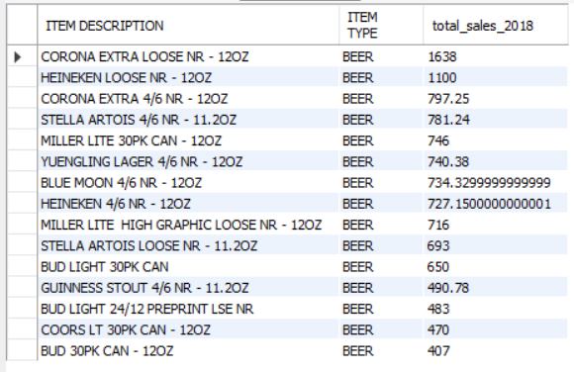
SELECT
`ITEM DESCRIPTION`,
`ITEM TYPE`,
SUM(`RETAIL SALES`) AS total_sales_2018
FROM warehouse_and_retail_sales
WHERE `YEAR` = '2018'
AND `ITEM TYPE` = 'Liquor'
GROUP BY `ITEM DESCRIPTION`, `ITEM TYPE`
ORDER BY total_sales_2018 DESC
LIMIT 15;
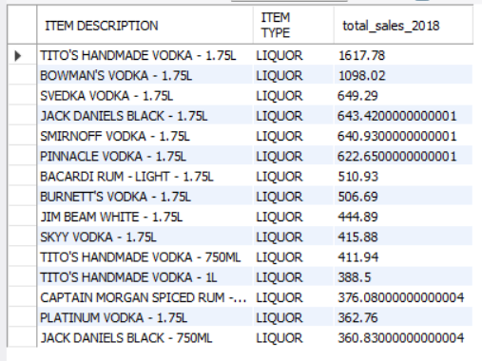
SELECT
`ITEM DESCRIPTION`,
`ITEM TYPE`,
SUM(`RETAIL SALES`) AS total_sales_2018
FROM warehouse_and_retail_sales
WHERE `YEAR` = '2018'
AND `ITEM TYPE` = 'Wine'
GROUP BY `ITEM DESCRIPTION`, `ITEM TYPE`
ORDER BY total_sales_2018 DESC
LIMIT 15;
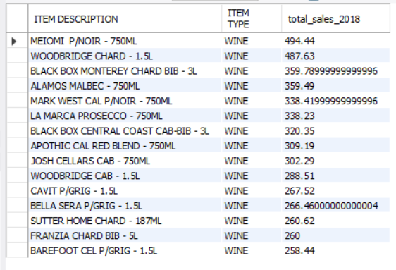
SELECT
`ITEM DESCRIPTION`,
`ITEM TYPE`,
SUM(`RETAIL SALES`) AS total_sales_2019
FROM warehouse_and_retail_sales
WHERE `YEAR` = '2019'
AND `ITEM TYPE` = 'Beer'
GROUP BY `ITEM DESCRIPTION`, `ITEM TYPE`
ORDER BY total_sales_2019 DESC
LIMIT 15;
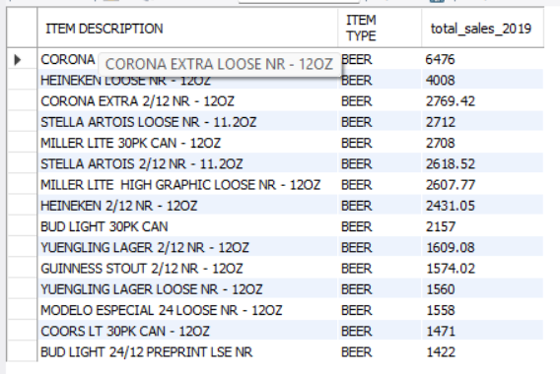
SELECT
`ITEM DESCRIPTION`,
`ITEM TYPE`,
SUM(`RETAIL SALES`) AS total_sales_2019
FROM warehouse_and_retail_sales
WHERE `YEAR` = '2019'
AND `ITEM TYPE` = 'Liquor'
GROUP BY `ITEM DESCRIPTION`, `ITEM TYPE`
ORDER BY total_sales_2019 DESC
LIMIT 15;
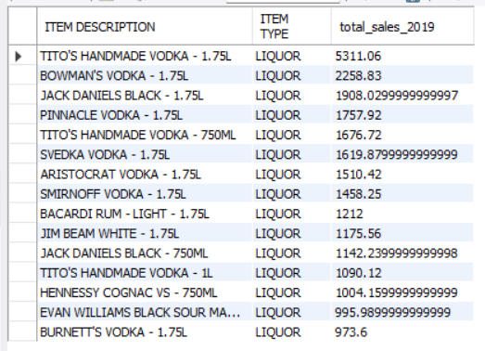
SELECT
`ITEM DESCRIPTION`,
`ITEM TYPE`,
SUM(`RETAIL SALES`) AS total_sales_2019
FROM warehouse_and_retail_sales
WHERE `YEAR` = '2019'
AND `ITEM TYPE` = 'Wine'
GROUP BY `ITEM DESCRIPTION`, `ITEM TYPE`
ORDER BY total_sales_2019 DESC
LIMIT 15;
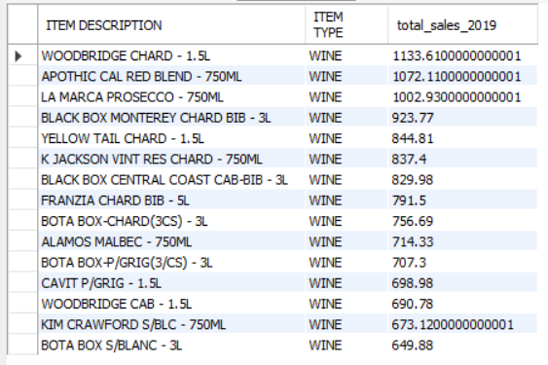
SELECT
`ITEM DESCRIPTION`,
`ITEM TYPE`,
SUM(`RETAIL SALES`) AS total_sales_2019
FROM warehouse_and_retail_sales
WHERE `YEAR` = '2019'
AND `ITEM TYPE` = 'Non-ALcohol'
GROUP BY `ITEM DESCRIPTION`, `ITEM TYPE`
ORDER BY total_sales_2019 DESC
LIMIT 5;
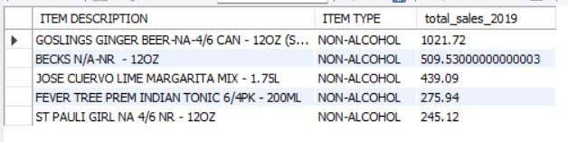
SELECT
`ITEM DESCRIPTION`,
`ITEM TYPE`,
SUM(`RETAIL SALES`) AS total_sales_2020
FROM warehouse_and_retail_sales

WHERE `YEAR` = '2020'
AND `ITEM TYPE` = 'Beer'
GROUP BY `ITEM DESCRIPTION`, `ITEM TYPE`
ORDER BY total_sales_2020 DESC
LIMIT 15;
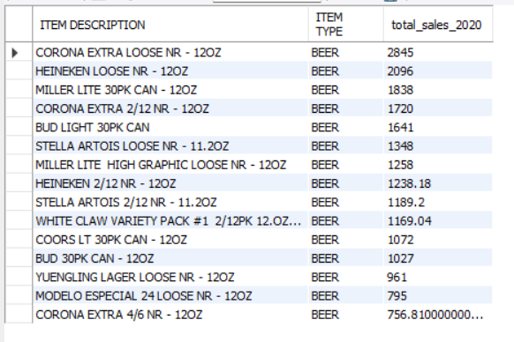
SELECT
`ITEM DESCRIPTION`,
`ITEM TYPE`,
SUM(`RETAIL SALES`) AS total_sales_2020
FROM warehouse_and_retail_sales
WHERE `YEAR` = '2020'
AND `ITEM TYPE` = 'Liquor'
GROUP BY `ITEM DESCRIPTION`, `ITEM TYPE`
ORDER BY total_sales_2020 DESC
LIMIT 15;
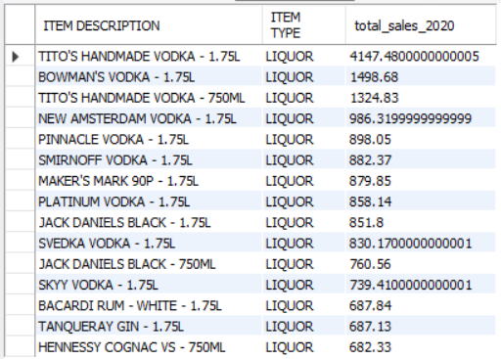
SELECT
`ITEM DESCRIPTION`,
`ITEM TYPE`,
SUM(`RETAIL SALES`) AS total_sales_2020
FROM warehouse_and_retail_sales
WHERE `YEAR` = '2020'
AND `ITEM TYPE` = 'Wine'
GROUP BY `ITEM DESCRIPTION`, `ITEM TYPE`
ORDER BY total_sales_2020 DESC
LIMIT 15;
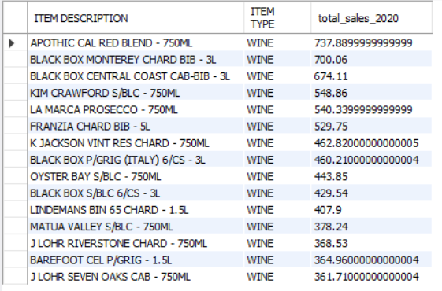
SELECT
`ITEM DESCRIPTION`,
`ITEM TYPE`,
SUM(`RETAIL SALES`) AS total_sales_2020
FROM warehouse_and_retail_sales
WHERE `YEAR` = '2020'
AND `ITEM TYPE` = 'Non-Alcohol'
GROUP BY `ITEM DESCRIPTION`, `ITEM TYPE`
ORDER BY total_sales_2020 DESC
LIMIT 5;
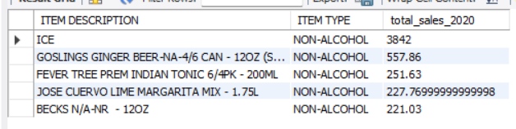
SELECT
YEAR,
SUM(`WAREHOUSE SALES`) as total_warehouse_sales
FROM warehouse_and_retail_sales
GROUP BY YEAR
ORDER BY total_warehouse_sales DESC;
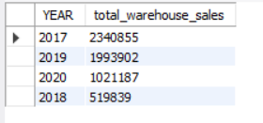
SELECT
`ITEM DESCRIPTION`,
SUM(`WAREHOUSE SALES`) as total_sales
FROM warehouse_and_retail_sales
GROUP BY `ITEM DESCRIPTION`
ORDER BY total_sales DESC
LIMIT 10;
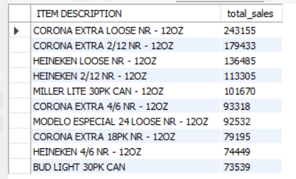
SELECT
`ITEM DESCRIPTION`,
SUM(`WAREHOUSE SALES`) AS top_keg_sales_2017
FROM warehouse_and_retail_sales
WHERE `YEAR` = '2017'
AND `ITEM TYPE` = 'Kegs'
GROUP BY `ITEM DESCRIPTION`
ORDER BY top_keg_sales_2017 DESC
LIMIT 15;
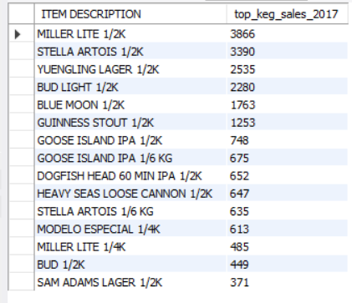
SELECT
`ITEM DESCRIPTION`,
SUM(`WAREHOUSE SALES`) AS top_keg_sales_2018
FROM warehouse_and_retail_sales
WHERE `YEAR` = '2018'
AND `ITEM TYPE` = 'Kegs'
GROUP BY `ITEM DESCRIPTION`
ORDER BY top_keg_sales_2018 DESC
LIMIT 15;
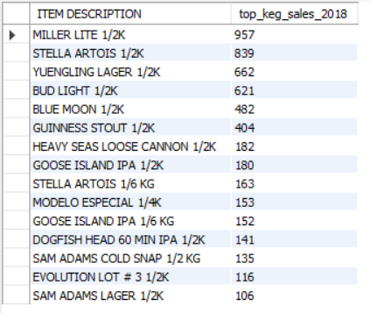
SELECT
`ITEM DESCRIPTION`,
SUM(`WAREHOUSE SALES`) AS top_keg_sales_2019
FROM warehouse_and_retail_sales
WHERE `YEAR` = '2019'
AND `ITEM TYPE` = 'Kegs'
GROUP BY `ITEM DESCRIPTION`
ORDER BY top_keg_sales_2019 DESC
LIMIT 15;
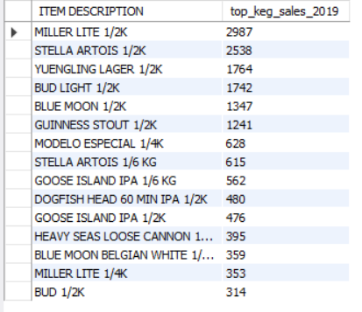
SELECT
`ITEM DESCRIPTION`,
SUM(`WAREHOUSE SALES`) AS top_keg_sales_2020
FROM warehouse_and_retail_sales
WHERE `YEAR` = '2020'
AND `ITEM TYPE` = 'Kegs'
GROUP BY `ITEM DESCRIPTION`
ORDER BY top_keg_sales_2020 DESC
LIMIT 15;
